Exno: 17

Date:

High level language extension with cursors

AIM:

To write a cursor program using MYSQL to retrieve the email- id of employees from employees table.

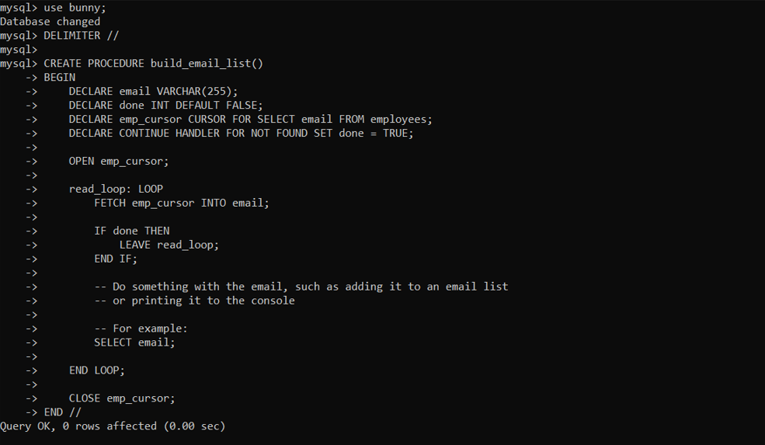

**RESULT:**

A cursor program using MYSQL to retrieve the email- id of employees from employees table is successfully executed and verified.